Sanjana R Pamadi Sharanya S Shetty
SDMCET SDMCET
Design and Implementation of a UART Module for High-Speed Serial Communication
Dharwad, India Dharwad, India

Sanjana S Ugran Shraddha G Mane
SDMCET SDMCET
Dharwad, India Dharwad, India
sanjanaugran73@gmail.com shraddha08mane@gmail.com

Abstract— The remarkable innovations in technology are driven mainly by the high speed data communication requirements of the modern generation. The Universal Asynchronous Receiver Transmitter (UART) is one of the most sought-after communication protocols. This work mainly focuses on implementing and analysing the UART for data communication. The system includes a baud rate generator, transmitter, and receiver to ensure accurate, low-latency, and error-free data transfer. A hardware-based approach minimizes inefficiencies, making it suitable for high-speed and real-time applications. The design is tested through simulation to verify its functionality and performance. This UART module can be integrated into FPGA and embedded systems, ensuring seamless communication with minimal resource utilization. Power-Efficient FSM based UART is also implemented using FSM. The Finite State Machine (FSM) implements the baud rate generator, transmitter, and receiver modules. Cadence NCSIM was utilized for simulation, and Cadence RTL Compiler was used during synthesis using the 45 nm and 90 nm General Process Design Kit (GPDK) library files. The experimental results show that the receiving and sending module of this module works well and meets the requirements of full-duplex serial communication equipment. There is no doubt that the design of this paper has made a more detailed explanation of the basic operating principle of UART, which will contribute to its further development.

INTRODUCTION
Universal Asynchronous Receiver/Transmitter is a universal serial data bus, which can meet the needs of information transmission between peripherals and computers, greatly increasing the efficiency of information transmission, and achieving full-duplex serial communication. It was a major milestone in the history of computing. This paper will fully understand the structure and principle of UART, function and implementation on the basis of the use of HDL language, by

describing its function, to achieve the construction of UART. By writing the code and running the simulation, the results this paper get agree with the expectation, which proves the feasibility of the construction method. UART can be divided into sending module and receiving module according to functions. It transmits binary codes bit by bit and receives binary codes bit by bit. It is worth noting that in order to take into account the accuracy and efficiency of information transmission, the sending module and the receiving module have different methods of confirming information.

RATIONALE

The need for efficient and reliable serial communication in digital systems has made UART one of the most commonly used protocols in embedded and computer-based applications. Unlike parallel communication, which requires multiple data lines, UART uses only two data lines—transmit (TX) and receive (RX)—making it cost-effective and easy to implement in hardware-constrained environments.Designing and implementing UART using Verilog HDL provides several advantages. allows for precise modeling of digital circuits, enabling customization and optimization of the UART module for different applications. Additionally, implementing UART in hardware (such as FPGA or ASIC) improves performance compared to software-based serial communication solutions.

PROBLEM STATEMENT

This project addresses the challenge of designing and implementing a UART module using HDL to ensure accurate, low-latency, and serial communication. The goal is to develop a UART system that includes a baud rate generator, transmitter, and receiver, ensuring seamless data transfer with proper synchronization and minimal resource utilization. The proposed design will be tested and verified through simulation to ensure its effectiveness in FPGA- based and embedded system applications.

OBJECTIVES

To understand the concept of UART serial communication and also by implementing this using HDL we get familiar with HDL like VHDL/Verilog with tools like Xilinx ISE/Cadence. 2. To implement a structured approach for UART transmitter module and receiving module. 3. To generate a precise baud rate clock for proper timing synchronization between sender and receiver using FSM. 4. To integrating all modules and simulating to verify results through waveform in Xlinix/ Cadence tool.

LITERATURE REVIEW
1. Kamath, A., Mendez, T., Ramya, S., & Nayak, S. G. Design and Implementation of Power-Efficient FSM based UART. Journal of Physics: Conference Series, 2022, 2161(1), 012052. This work mainly focuses on implementing and analysing the UART for data communication. The Finite State Machine (FSM) implements the baud rate generator, transmitter, and receiver modules. Cadence NCSIM was utilized for simulation, and Cadence RTL Compiler was used during synthesis using the 45 nm and 90 nm General Process Design Kit (GPDK) library files. The baud rate of 9600 bps and 50 MHz clock frequency was used to design UART. The increased speed and complexity of the VLSI chip designs has resulted in a significant increase in power consumption. The comparative analysis of power and delay for different clock periods shows an improvement in the total power and the Power Delay Product (PDP) with increasing clock periods. Better results were observed using 45 nm in comparison to the 90 nm library

2.R, Y., & V, R. M. Design and Verification of UART using System Verilog. International Journal of Engineering and Advanced Technology, 2020,9(5), 1208–1211. The main objective of this paper is to design and verify a full duplex UART module using System Verilog (SV). It is a serial communication protocol which provides communication between the systems without using clock signal. It converts parallel data into serial format and transmits the same. Once the data in serial format is received it is converted into parallel format. Designing of UART includes designing of baud rate generator, receiver, transmitter, interrupt and FIFO modules. Verification involves verifying the design by creating verification environment which allows to reuse the testbench and reduces the code complexity.

3.Amrit P. Singh, Khushboo Gupta, & Juhee Mala. Determination of UART Receiver Baud Rate Tolerance. International Conference on Computer and Communication Technology, 2015, 265–270, 2818655 .A complete system can consist of heterogeneous devices communicating with each other through UART interface, where each such device is capable of generating a different baud rate depending upon its source clock, also known as Baud Clock (which could be derived from PLLs or Oscillator). The Basic Principle of UART Protocol defines that the Transmitter and Receiver should be configured at the same baud rate to communicate correctly. There are some clock dividers implemented within and/or external to the module in order to achieve the same.

4.Choi, J. I., Jain, M., Srinivasan, K., Levis, P., & Katti, S. Achieving single channel, full duplex wireless communication. Proceedings of the Sixteenth Annual International Conference on Mobile Computing and Networking - MobiCom ’10, 2010, 1859997. This paper discusses the design of a single channel full-duplex wireless transceiver. The design uses a combination of RF and baseband techniques to achieve full-duplexing with minimal effect on link reliability. Experiments on real nodes show the full-duplex prototype achieves median performance that is within 8% of an ideal full-duplexing system.This paper presents Antenna Cancellation, a novel technique for self-interference cancellation. In conjunction with existing RF interference cancellation and digital baseband interference cancellation, antenna cancellation achieves the amount of self-interference cancellation required for full-duplex operation.The paper also discusses potential MAC and network gains with full-duplexing.

METHODOLOGY/PLANNING OF WORK
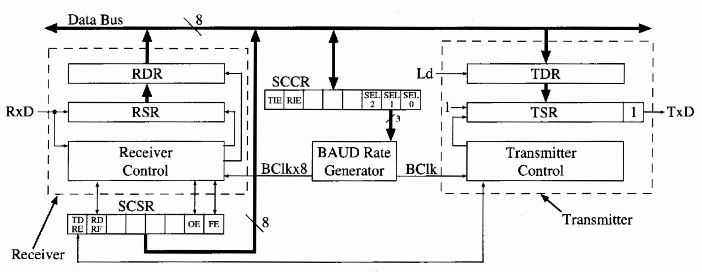
Fig(1)UART Block Diagram

Implementation Details

1.Baud Rate Generator (BRG)

The Baud Rate Generator is a crucial component of UART that determines the rate at which data bits are transmitted and received. It acts as a frequency divider circuit that converts the system clock into a baud clock used by both the transmitter and receiver modules.

Automatic baud rate detection
Automatic baud rate detection enables a UART system to identify the correct baud rate dynamically by iteratively configuring the UART peripheral with standard baud values and analyzing incoming data. The system listens for valid byte patterns, such as printable ASCII characters or synchronization markers like 0x55, within a short timeout window. If a sufficient number of valid bytes are detected, the baud rate is considered correct, and the UART is configured accordingly. This technique eliminates the need for fixed baud rate settings and ensures reliable communication across various devices or environments where baud rates may vary or be unknown.

Algorithm: UART Auto Baud Rate Detection
Step Step 1: Initialization
A)Define a list of standard baud rates (e.g., 9600, 115200, etc.).
B)Set up UART peripheral (platform-dependent: STM32, Arduino, etc.).
C)Prepare receive buffer and timing functions.

Step 2: Loop Through Baud Rates
For each baud_rate in the list:
A)Configure UART with the current baud_rate.
B)Flush UART receive buffer to clear any old data.

Step 3: Wait for Incoming Data
A)Start a timer (e.g., 200–500 ms).
B)While the timeout hasn’t been reached:
-If data is received, store it in a local buffer.
-Count number of valid characters, e.g.:
-Printable ASCII (letters, digits, symbols)
-Sync characters (0x55, 0xAA)
-Newlines or tabs ('\r', '\n', '\t')

Step 4: Analyze Received Data
If:
-Enough bytes are received, and
-A high percentage (e.g., >70%) of them are valid
Then:
-Assume baud rate is correct.
-Return this baud_rate as the detected value.

Step 5: Continue or Fallback
A)If no valid data found:
-Move to the next baud rate.
B)If none match:
-Use a default baud rate (e.g., 9600).

Step 6: Start Communication
A)Re-configure UART with the detected baud rate.
B)Begin normal UART communication.

2. Transmitter Module

The Transmitter converts 8-bit parallel data from the source into a serialized data stream. This data is framed with start, parity, and stop bits to form a complete UART frame for transmission.In the idle state, the transmitter is halted until a logic high is given to the start signal. The input is fed in parallel to the registers when the start bit is one. After completing the LOAD operation, the next state is DATAwhen COUNT=15forthe shift operation as it converts the data from parallel to serial using the PISO shift register. After the shift operation, the OUT becomes 1. The parity generator generates parity for 8-bit input data by EXOR operation and PAR =1. The transmitter then sends the stop bit and converts the logic to high. Then all these bits are sent serially as one data packet at the DATA_OUT.
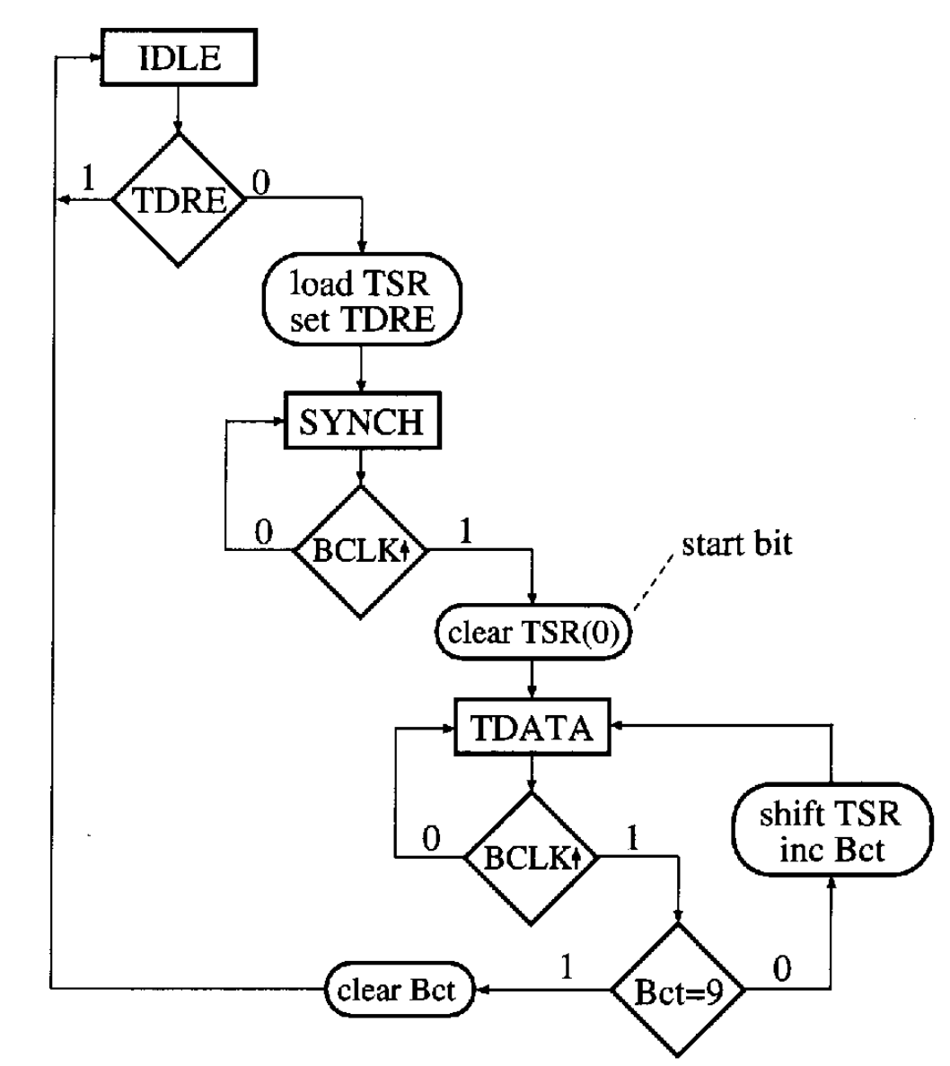
Fig(2) SM Chart for UART Transmitter

3. Receiver Module

The data conversion from serial to parallel is obtained using the UART Receiver module as shown in Figure 4. This conversion takes place using the FSM. The receiver module is in the IDLE STATE when continuous ones are detected. When logic is low, the next state DATA starts to receive the data when the DETECT_BIT=1 and the shift operation is done. If COUNT=7, then the next state is for parity. If RX_COUNT=15then the parity check has been done successfully. When the receiver detects the stop bit, it moves to the ideal state, and all the data bits are sent parallelly in RX_DATA_OUT. The Receiver performs the reverse operation of the transmitter. It accepts the incoming serial bitstream, identifies the frame boundaries, validates parity, and then reconstructs the original 8-bit parallel data using a shift register.

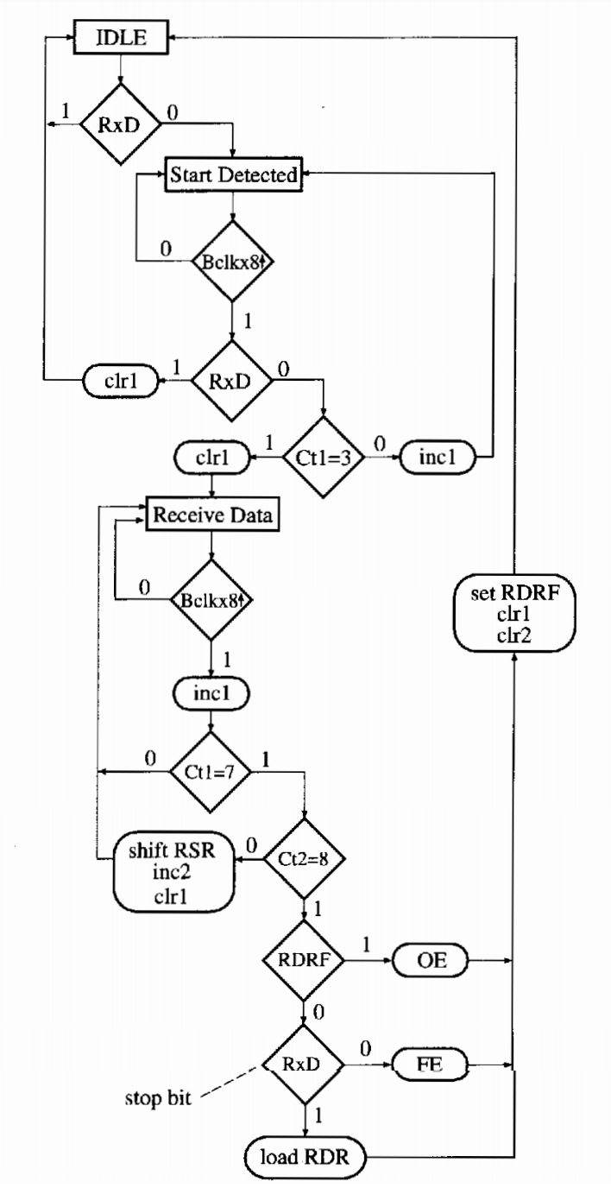
Fig(3).SM Chart for UART Receiver

APPROACH

Step 1: Define UART Frame Structure - A UART (Universal Asynchronous Receiver Transmitter) frame consists of bits that define how data is transmitted serially.

Step 2: Divide UART into Functional Modules- Transmitter Module (Tx) , Receiver Module (Rx) ,Baud Rate Generator

Step 3: Design UART Transmitter - A UART Transmitter converts parallel data into a serial bitstream and sends it with proper timing, start/stop bits, and optional parity.
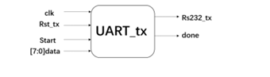

Step 4:UART Receiver Design - A UART Receiver is responsible for receiving serial data, converting it to parallel data, and verifying its correctness using start, stop, and optional parity bits.
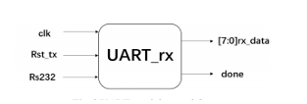

Step 5: Implement Baud Rate Generator - A Baud Rate Generator (BRG) is responsible for generating timing pulses to control the transmission and reception of UART data at a specific baud rate (e.g., 9600, 115200 bps).

Step 6: Integrate All Modules - Combine Tx, Rx, and Baud Rate Generator in the UART module.

Step 7: Simulate in Xlinix/Cadence - Test transmission (Tx) and reception (Rx) separately.Check if serial data matches expected output. Verify correct start, data, and stop bit positioning.

Step 8: Verifying results through waveforms- verfying transmitter receiver modules separately by waveforms

SOFTWARE REQUIRED FOR THE DEVELOPMENT OF THE PROJECT
Xilinx ISE Xilinx ISE (Integrated Software Environment) is a comprehensive FPGA design tool used for developing digital circuits using FSM and VHDL. It provides a complete workflow from design entry to simulation, synthesis, and hardware implementation. In the context of UART (Universal Asynchronous Receiver-Transmitter) design, Xilinx ISE plays a crucial role in verifying and deploying communication systems. How Xilinx ISE Helps in UART Design and Implementation 1. Design Entry & Coding
• Xilinx ISE provides an integrated text editor where engineers can write HDL code for UART transmission and reception.
• It supports syntax highlighting, error checking, and easy debugging for efficient code development. 2. Simulation & Debugging
• Using ISim, the built-in simulator, users can simulate the UART communication process before implementing it on hardware.
• It allows visualization of UART signals, such as the start bit, data bits, stop bit, and baud rate timing.
• Engineers can check whether the transmitted data matches the received data, ensuring reliable communication. 3. Synthesis & Optimization
• Xilinx ISE synthesizes the Verilog code into a gate-level netlist, making it suitable for FPGA implementation.
It optimizes the design for resource efficiency, ensuring the UART module operates with minimal power and hardware usage. 4. Implementation & Place-and-Route
• The tool maps the synthesized design onto an FPGA, assigning logic resources for proper functionality.
• Place-and-route ensures that timing constraints are met, preventing data corruption due to clock mismatches. 5. Bitstream Generation & Hardware Deployment
• Once the design is successfully implemented, Xilinx ISE generates a .bit file, which is used to program the FPGA. Dept of EEE, SDMCET, Dharward 8
• This allows real-world testing of UART communication, ensuring reliable serial data transmission between devices.

RESULTS
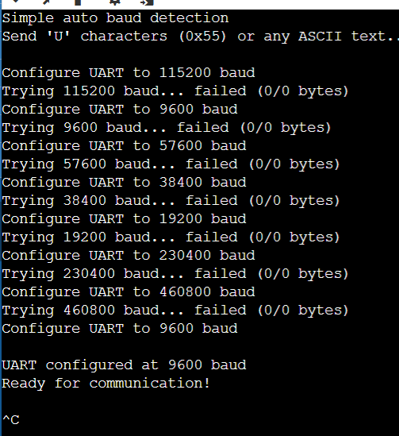
fig(4) Auto Baud Rate Outcome

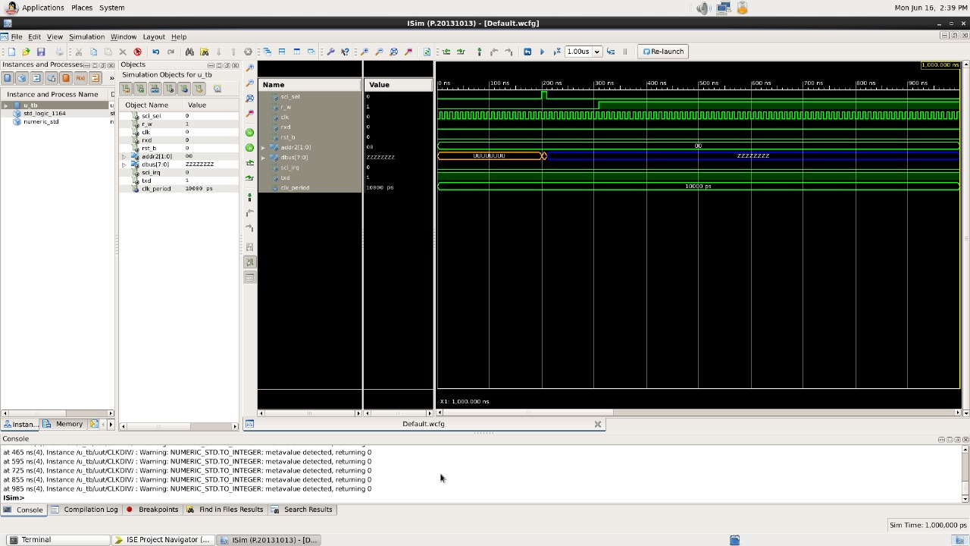
fig (5) Top Model Outcome

Future Scope
The successful implementation of UART with an automatic baud rate detection feature demonstrates the potential for developing more intelligent and adaptive communication interfaces. In future work, this UART module can be extended to support dynamic reconfiguration at runtime, allowing seamless communication with multiple devices operating at different baud rates without manual intervention. Additional features such as DMA(Direct Memory Access) support, parity and framing error detection, and flow control mechanisms (like RTS/CTS) can be integrated to enhance reliability and performance in complex systems. The auto baud rate detection module itself can be optimized for faster lock-in time and improved accuracy under noisy or unstable line conditions. Furthermore, the UART design can be embedded into multi-core FPGAsystems or SoCs, enabling high-speed communication in real-time embedded applications, industrial automation, and IoT ecosystems. This project also serves as a foundation for building more complex protocol converters and smart communication bridges between legacy serial devices and modern networks.

CONCLUSION
The design and implementation of a Universal Asynchronous Receiver Transmitter (UART) using HDL has successfully demonstrated the practical application of digital communication principles in hardware. The developed module supports essential UART functionalities along with an advanced feature—automatic baud rate detection—allowing flexible and adaptive serial communication without manual configuration. Through simulation, synthesis, and optional FPGA deployment, the system was verified for accuracy, reliability, and real-time performance. This project not only deepened the understanding of hardware modeling and asynchronous data transfer but also provided valuable insights into designing scalable and configurable communication interfaces. The work serves as a solid foundation for further enhancements and integration into larger embedded or networked systems.
Acknowledgment
We would like to express our sincere gratitude to GM University, Davanagere, for providing the opportunity to present this work at the National Conference on Smart Systems and Emerging Trends in Electronics & Electrical Engineering ,NCSEEE 2025. We extend our thanks to the Department of Electrical and Electronics Engineering, SDM College of Engineering and Technology, Dharwad, for their continuous guidance, encouragement, and support throughout the course of this work.We would also like to thank our guide, Mr. Pradeep Vibhuti, for his invaluable guidance, constant encouragement, and insightful suggestions, which have been instrumental in the successful completion of this paper.
Finally, we acknowledge the efforts of the conference organizers, faculty members, and reviewers for their valuable feedback, which greatly contributed to improving the quality of this work.
References
[1] Thai, N. P., Ngoc, B. H., Duy, T. D., Truong, P. Q., & Phan, V. C. A novel multichannel UART design with FPGA-based implementation. International Journal of Computer Applications in Technology, 2021, 67(4), 358.

[2] R, Y., & V, R. M. Design and Verification of UART using System Verilog. International Journal of Engineering and Advanced Technology, 2020,9(5), 1208–1211.

[3] Kamath, A., Mendez, T., Ramya, S., & Nayak, S. G. Design and Implementation of Power-Efficient FSM based UART. Journal of Physics: Conference Series, 2022, 2161(1), 012052.

[4] Amrit P. Singh, Khushboo Gupta, & Juhee Mala. Determination of UART Receiver Baud Rate Tolerance. International Conference on Computer and Communication Technology, 2015, 265–270, 2818655.

[5] Kashyap, B., & Ravi, V. Universal Verification Methodology Based Verification of UART Protocol. Journal of Physics: Conference Series, 2020, 1716(1), 012040. [6] HU, Z., ZHANG, J., & LUO, X. L. A Novel Design of Efficient Multi-channel UART Controller Based on FPGA. Chinese Journal of Aeronautics, 2007,20(1), 66–74.

